**A Project Synopsis of**

**EMPLOYEE MANAGEMENT SYSTEM**

**submitted**

**BY**

**Sunny kumar**

**Submitted To**

**Junie Denny Solomon**

**(SKILL LYNC)**

* **CONTENTS**

* **INTRODUCTION**
* **OBJECTIVES OF THE PROJECTS**
* **BENEFITS**
* **METHODLOGY**
* **EQUOPEMENT AND TOOLS**
* **CONCLUSION**

* **INTRODUCTION**
* **This project is all about software for**

**Employee management system. It helps to have**

**a full-fledged control over his/her employee. The**

**project is divided into 2 sections to make the**

**programme easy to understand.**

* **It makes the record of user salary , his**

**Department of working ,his performance in the**

**Office. It adds a new employee, his salary ,**

**Department , update an existing salary, list of**

**Employee, age his performance.**

* **OBJECTIVES OF THE PROJECT**
* The objective of this project is to let the students

Apply the programming knowledge into real-word

Situation/problem and exposed the students how

Programming skills in developing a good software.

1. Write programs utilizing modern software tools.
2. Apply object oriented programming principles

Efficiently when developing small to medium projects .

1. Write effective procedural code to solve small to medium sized problems.
2. Students will demonstrate a breadth of knowledge in computer science, as exemplified in the areas of systems, theory and software development.
3. Students will demonstrate ability to conduct a research

Or applied computer science project, requiring and skill which exemplify scholarly style in computer science.

* **BENIFITS**
* The objective of this project is to provide a comprehensive approach towards the management of employee information. Provides full functional reports to the managements of compony. To develop a well desingned database to store employee information. This project aims to simplify the task of maintaining records of the employee Company.
* **METHODLOGY**

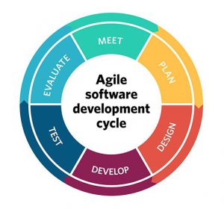

Agile is an approach to software development that seeks the continuous delivery of working software created in rapid iterations.

However, the phrase "agile methodology" is misleading because it implies that agile is a singular approach to software development

* **Equipment and Tools**
* **JAVA**
* **MySql**
* **JDBC Driver**
* **CONCLUSION**
* **Software for employee management system**

**Helps your organization improve workforce**

**Productivity and boost overall well-being by**

**Tracking and monitoring the daily working**

**Activities of every employee.**